ASTRACT

in today’s life is being controlled by technology and everyone tends to have a kind control on their decoration, and this project is designed for helping people living with preparation their party and also to help parents to have decoration on their homes when they want to celebrating any kind of party we are to gather with family and actually in same cases an old person can also be helped with this project that why I decided to design and to implement this project called “TURNING ON BULBS LAMPS USING PUSHBUTTON FOR DECOLATION PURPOSE ” to allow the mentioned people to control lights their decoration in this project will need to use software and hardware components such us Arduino Uno board ,pushbutton and lamps.

PROBLEM STATEMENT

Rwanda is developing country where the digital electronic control systems using pushbutton cannot stand a high level in control automatically. also, people need to control manage and reduce the tasks by this project Turning ON lamps using pushbutton for decoration purpose it can help Rwandans in their decoration who uses electrical appliances for switching some component like AC lamps and others different devices the project will help to solve the problem of switching some of decoration electrical appliances devices which will help some people who have celebrating party,

BLOCK DIAGRAM

LAMP1

LAMP2

4 CHANNEL OF RELAYS MODULE

ARDUINO UNO

LAMP3

LAMP4

REGURALATION DC PAWER SUPPLY

AC LINE 230V

**BLOCK DIAGRAM DESCRIPTION**

When supplied and we press the pushbutton, also pushbutton pulse will be sent to the microcontroller ATmega328p on Arduino Uno board which will convert the received analog a signal into digital signal which later is processed and the stage makes a decision and gives the output on the pin corresponding to the pin needed to be high or on and which pin need to be low or off in order to switch ON and OFF the relay R1, R2, R3, R4.

CIRCUIT DIAGRAM DROWN IN FRITZING

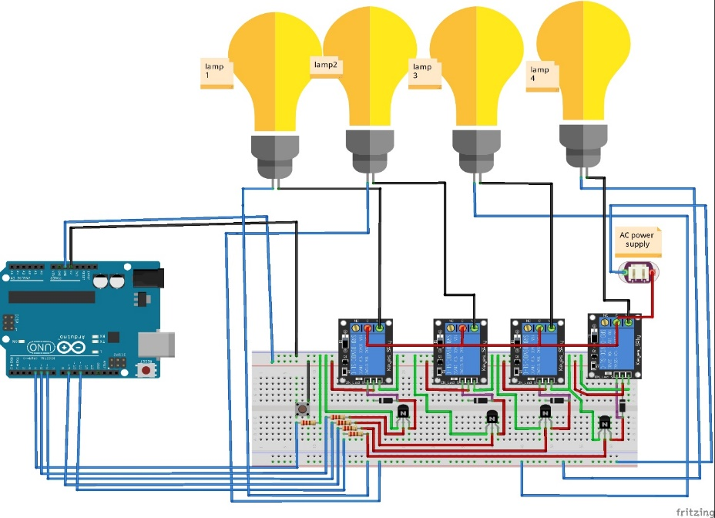

SIMULATION IN PROTEUS

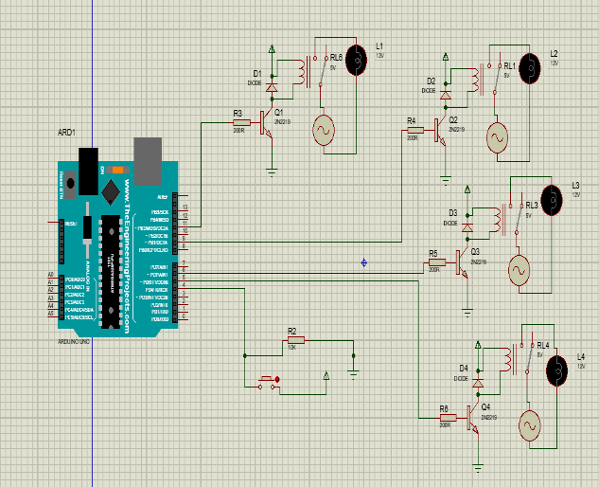

SOURCE CODES IN ARDUINO IDE

int led1=5;

int led2=7;

int led3=9;

int led4=13;

int x=4;

void setup() {

pinMode(5,OUTPUT);

pinMode(7,OUTPUT);

pinMode(9,OUTPUT);

pinMode(11,OUTPUT);

pinMode(4,INPUT_PULLUP);

Serial.begin(9600);

}

void loop() {

x=digitalRead(4);

if(x==HIGH)

if1:

{digitalWrite(5,HIGH);

digitalWrite(7,LOW);

digitalWrite(9,LOW);

digitalWrite(13,LOW);

delay(2000);

digitalWrite(5,LOW);

digitalWrite(7,HIGH);

digitalWrite(9,LOW);

digitalWrite(13,LOW);

delay(2000);

digitalWrite(5,LOW);

digitalWrite(7,LOW);

digitalWrite(9,HIGH);

digitalWrite(13,LOW);

delay(2000);

digitalWrite(13,HIGH);

digitalWrite(5,LOW);

digitalWrite(7,LOW);

digitalWrite(9,LOW);

delay(2000);

goto if1;

}

else{

digitalWrite(7,LOW);;

digitalWrite(5,LOW);

digitalWrite(9,LOW);

digitalWrite(13,LOW);

delay(2000);

}

}